**SMART PUBLIC RESTROOM**

**Feature Engineering**:

* + **Definition**: Feature engineering involves creating new features (variables) from the existing data to help the model better understand the underlying patterns. It's about selecting and transforming the right variables to improve the model's performance.
  + **Examples**:
    - Creating interaction terms between existing variables.
    - Binning or discretizing continuous variables.
    - One-hot encoding categorical variables.
    - Extracting meaningful information from text or images.

1. **Model Training**:
   * **Definition**: Model training involves using a dataset to teach a machine learning algorithm to recognize patterns and make predictions. During training, the model learns to adjust its internal parameters to minimize the difference between its predictions and the actual target values.
   * **Steps**:
     + **Data Preparation**: The dataset is typically split into training and validation sets.
     + **Initialization**: Model parameters are initialized randomly or using pre-trained weights (in transfer learning).
     + **Forward Propagation**: Data is passed through the model to make predictions.
     + **Loss Calculation**: The difference between predictions and actual targets (loss) is computed.
     + **Backpropagation**: Gradients are computed with respect to the loss, and parameters are updated to minimize it.
     + **Iterations (Epochs)**: The process is repeated for multiple iterations (epochs) until convergence.
     + **Validation**: Model performance is evaluated on a separate validation set to avoid overfitting.
2. **Model Evaluation**:
   * **Definition**: Model evaluation assesses how well the trained model generalizes to unseen data. It helps to understand how the model will perform on new, unseen examples.
   * **Metrics**:
     + **Classification**:
       - Accuracy, precision, recall, F1-score, ROC-AUC, etc.
     + **Regression**:
       - Mean Absolute Error (MAE), Mean Squared Error (MSE), R-squared, etc.
   * **Cross-Validation**: Splitting the data into multiple subsets and training/evaluating the model on each subset to get a more robust estimate of its performance.
   * **Bias-Variance Tradeoff**: Assessing the balance between underfitting and overfitting.
3. **Hyperparameter Tuning**:
   * **Definition**: This activity involves finding the best set of hyperparameters for a machine learning model. Hyperparameters are settings that are not learned during training (e.g., learning rate, regularization strength).
   * **Methods**:
     + Grid Search, Random Search, Bayesian Optimization, etc.
4. **Deployment** (optional):
   * **Definition**: If the model performs well, it can be deployed in a production environment to make real-time predictions.
   * **Considerations**:
     + Integration with existing systems.
     + Monitoring for performance and drift.

These activities collectively form the core of building and deploying machine learning models. Remember that this is an iterative process, and you might need to go back and refine earlier steps based on the results of later steps.

Top of Form

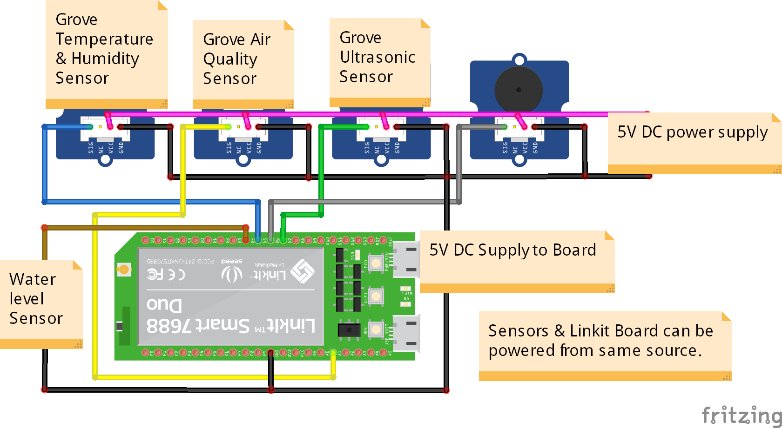

{

  "version": 1,

  "author": "Ashok Iyengar",

  "editor": "wokwi",

  "parts": [

    { "type": "wokwi-breadboard-mini", "id": "bb1", "top": 65.8, "left": -60, "attrs": {} },

    { "type": "wokwi-arduino-uno", "id": "uno", "top": 19.8, "left": 153, "attrs": {} },

    { "type": "wokwi-led", "id": "led1", "top": 63.6, "left": -63.4, "attrs": { "color": "red" } },

    {

      "type": "wokwi-resistor",

      "id": "r1",

      "top": 99.95,

      "left": -19.2,

      "attrs": { "value": "1000" }

    },

    {

      "type": "wokwi-pushbutton",

      "id": "btn1",

      "top": 140.6,

      "left": -38.4,

      "attrs": { "color": "green" }

    },

    { "type": "wokwi-servo", "id": "servo1", "top": -98, "left": -28.8, "attrs": {} }

  ],

  "connections": [

    [ "led1:A", "r1:1", "green", [ "v0", "h19.2" ] ],

    [ "led1:C", "uno:2", "green", [ "v-115.2", "h490" ] ],

    [ "r1:2", "uno:GND.1", "green", [ "v-115.2", "h286.8" ] ],

    [ "btn1:1.r", "uno:7", "green", [ "v-115.2", "h365" ] ],

    [ "btn1:2.r", "uno:GND.2", "green", [ "h355.4", "v48.2" ] ],

    [ "servo1:GND", "uno:GND.1", "black", [ "h-9.6" ] ],

    [ "servo1:V+", "uno:3.3V", "green", [ "h211.2", "v249.7" ] ],

    [ "servo1:PWM", "uno:9", "green", [ "h220.8", "v57.8" ] ],

    [ "led1:A", "bb1:2t.d", "", [ "$bb" ] ],

    [ "led1:C", "bb1:1t.d", "", [ "$bb" ] ],

    [ "r1:1", "bb1:4t.d", "", [ "$bb" ] ],

    [ "r1:2", "bb1:10t.d", "", [ "$bb" ] ],

    [ "btn1:1.l", "uno:7", "green", [ "h384", "v-124.8" ] ],

    [ "btn1:2.l", "uno:GND.2", "green", [ "h364.8", "v38.6" ] ],

    [ "btn1:1.l", "bb1:2b.g", "", [ "$bb" ] ],

    [ "btn1:2.l", "bb1:2b.i", "", [ "$bb" ] ],

    [ "btn1:1.r", "bb1:9b.g", "", [ "$bb" ] ],

    [ "btn1:2.r", "bb1:9b.i", "", [ "$bb" ] ]

  ],

  "dependencies": {}

}

{

  "version": 1,

  "author": "Ashok Iyengar",

  "editor": "wokwi",

  "parts": [

    { "type": "wokwi-breadboard-mini", "id": "bb1", "top": 65.8, "left": -60, "attrs": {} },

    { "type": "wokwi-arduino-uno", "id": "uno", "top": 19.8, "left": 153, "attrs": {} },

    { "type": "wokwi-led", "id": "led1", "top": 63.6, "left": -63.4, "attrs": { "color": "red" } },

    {

      "type": "wokwi-resistor",

      "id": "r1",

      "top": 99.95,

      "left": -19.2,

      "attrs": { "value": "1000" }

    },

    {

      "type": "wokwi-pushbutton",

      "id": "btn1",

      "top": 140.6,

      "left": -38.4,

      "attrs": { "color": "green" }

    },

    { "type": "wokwi-servo", "id": "servo1", "top": -98, "left": -28.8, "attrs": {} }

  ],

  "connections": [

    [ "led1:A", "r1:1", "green", [ "v0", "h19.2" ] ],

    [ "led1:C", "uno:2", "green", [ "v-115.2", "h490" ] ],

    [ "r1:2", "uno:GND.1", "green", [ "v-115.2", "h286.8" ] ],

    [ "btn1:1.r", "uno:7", "green", [ "v-115.2", "h365" ] ],

    [ "btn1:2.r", "uno:GND.2", "green", [ "h355.4", "v48.2" ] ],

    [ "servo1:GND", "uno:GND.1", "black", [ "h-9.6" ] ],

    [ "servo1:V+", "uno:3.3V", "green", [ "h211.2", "v249.7" ] ],

    [ "servo1:PWM", "uno:9", "green", [ "h220.8", "v57.8" ] ],

    [ "led1:A", "bb1:2t.d", "", [ "$bb" ] ],

    [ "led1:C", "bb1:1t.d", "", [ "$bb" ] ],

    [ "r1:1", "bb1:4t.d", "", [ "$bb" ] ],

    [ "r1:2", "bb1:10t.d", "", [ "$bb" ] ],

    [ "btn1:1.l", "uno:7", "green", [ "h384", "v-124.8" ] ],

    [ "btn1:2.l", "uno:GND.2", "green", [ "h364.8", "v38.6" ] ],

    [ "btn1:1.l", "bb1:2b.g", "", [ "$bb" ] ],

    [ "btn1:2.l", "bb1:2b.i", "", [ "$bb" ] ],

    [ "btn1:1.r", "bb1:9b.g", "", [ "$bb" ] ],

    [ "btn1:2.r", "bb1:9b.i", "", [ "$bb" ] ]

  ],

  "dependencies": {}

}